Observations:

1. The name of signup button is not as per wireframe.

Application signup page:

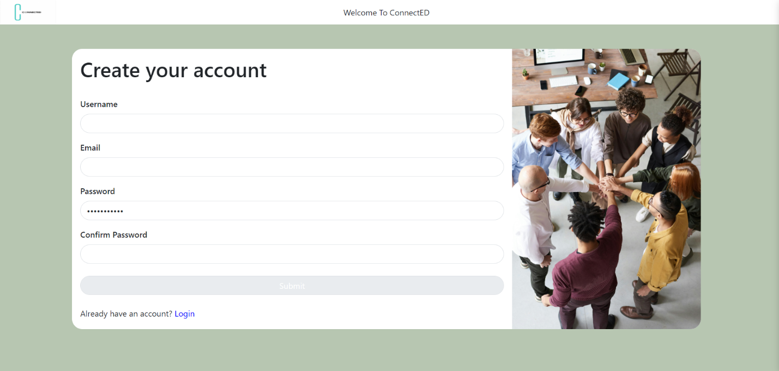

Wireframe:

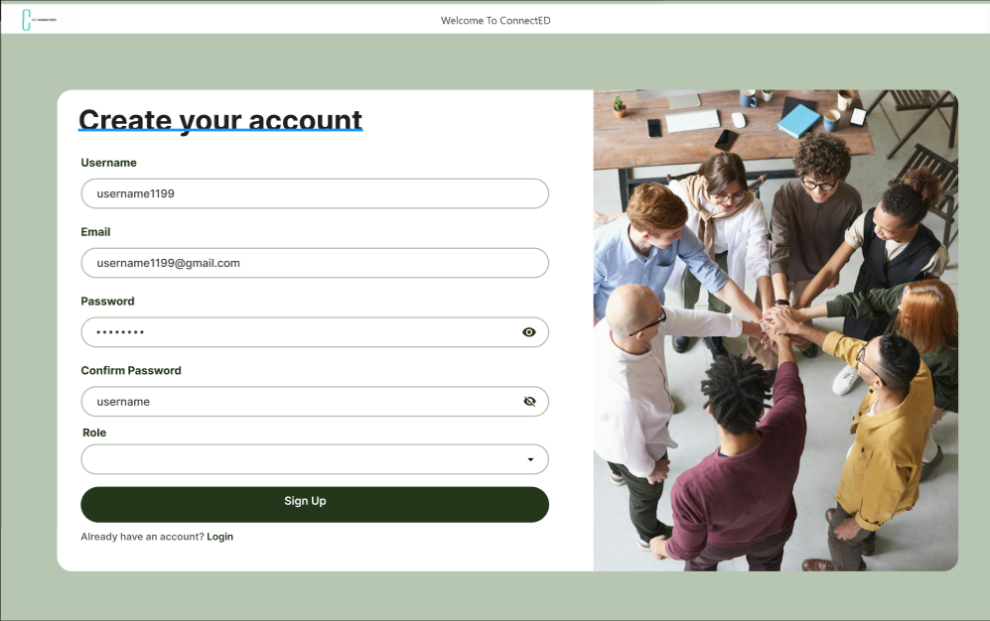

1. A message should display confirming that the email already exists if a user has already registered with that email.

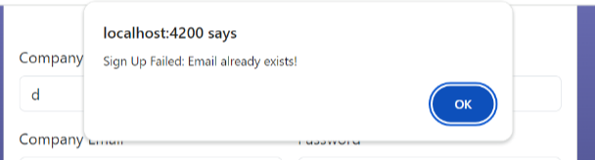

User1 already exist in the DB.

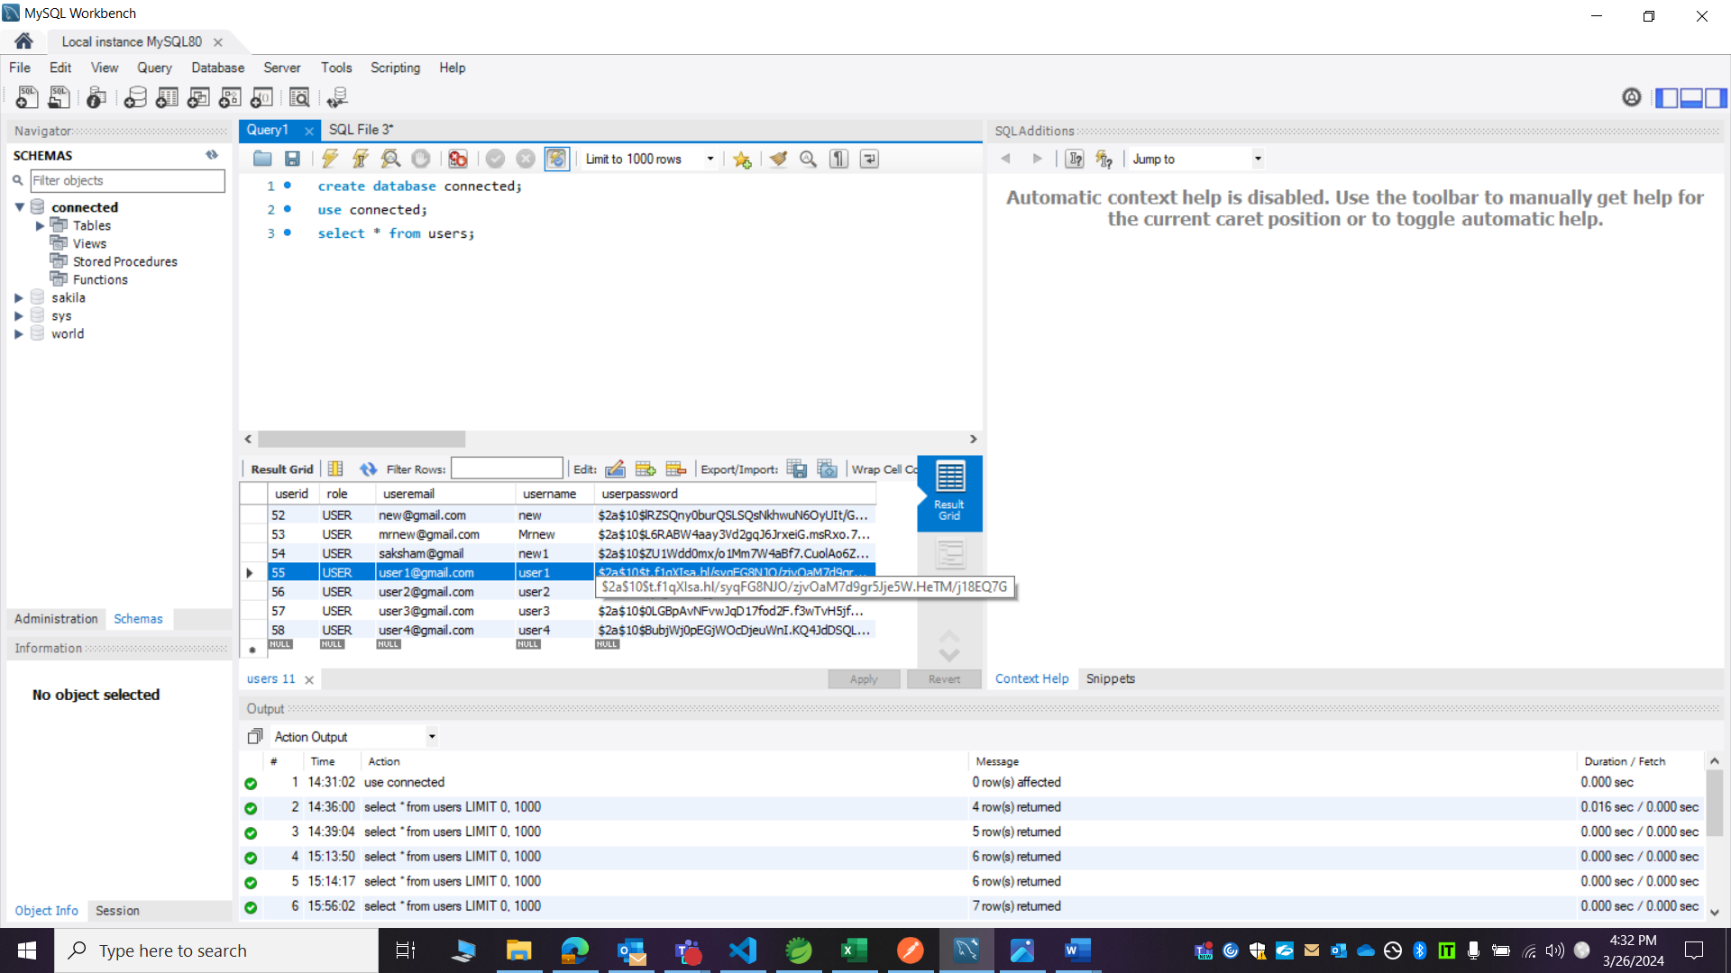

1. Email field is accepting invalid format and not giving error based on the invalid format.

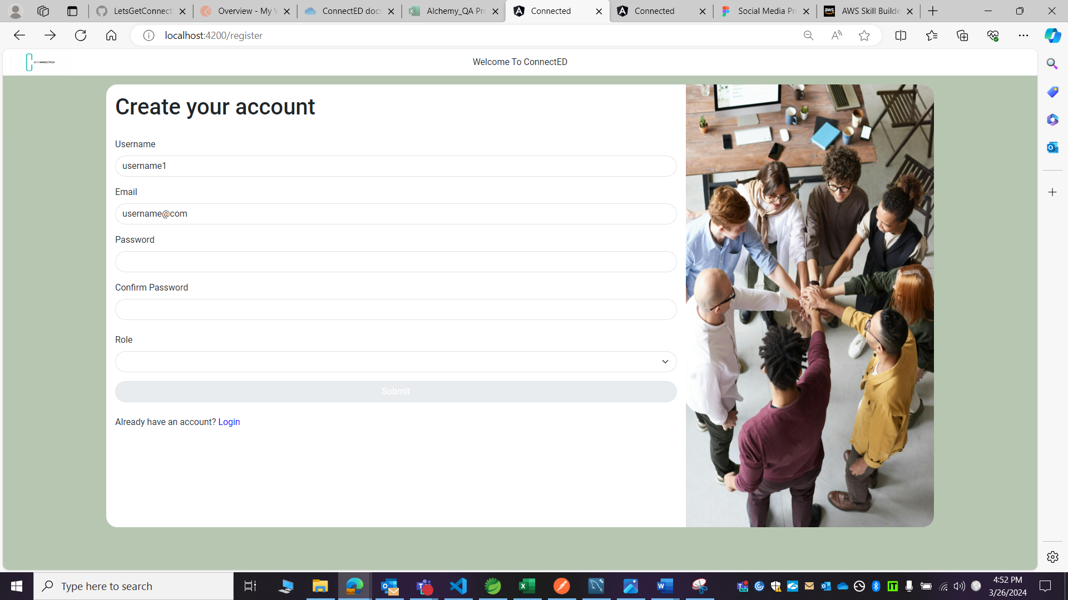

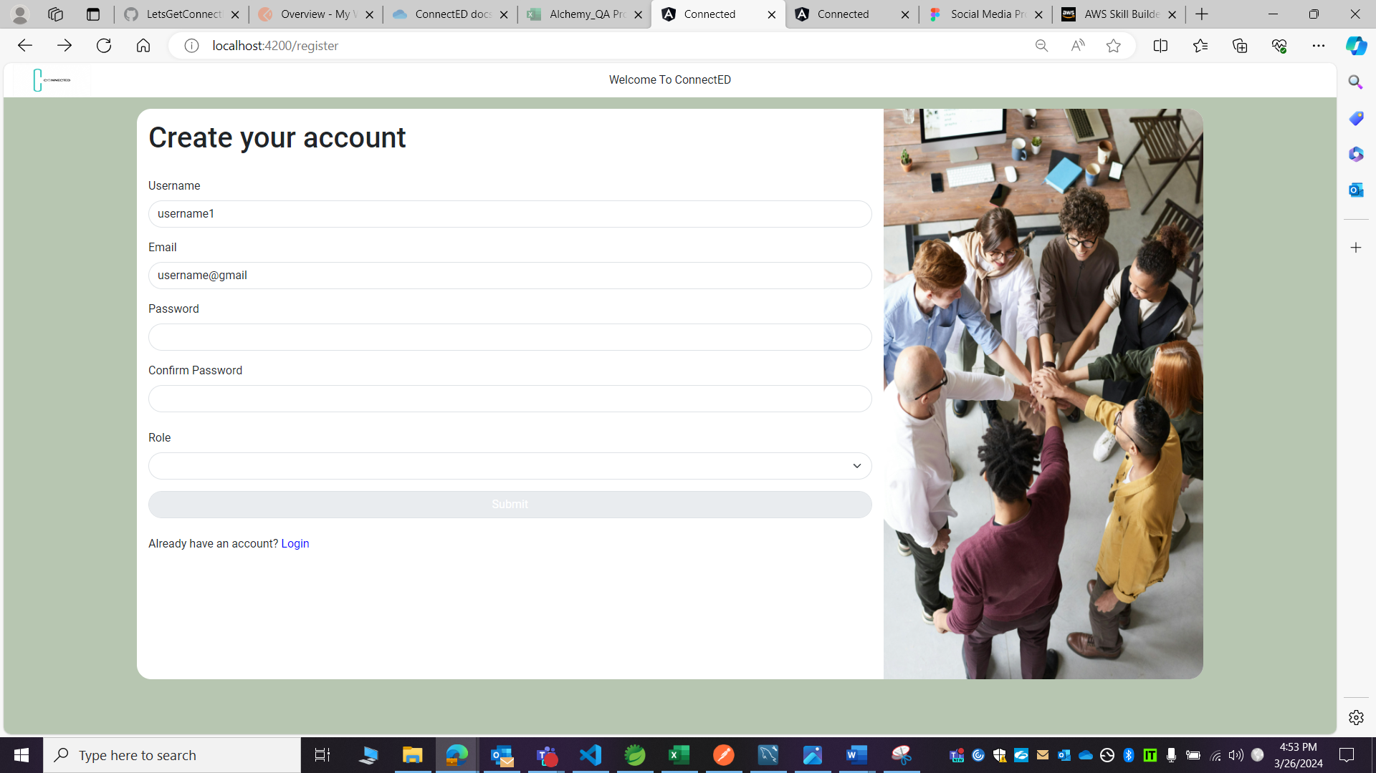

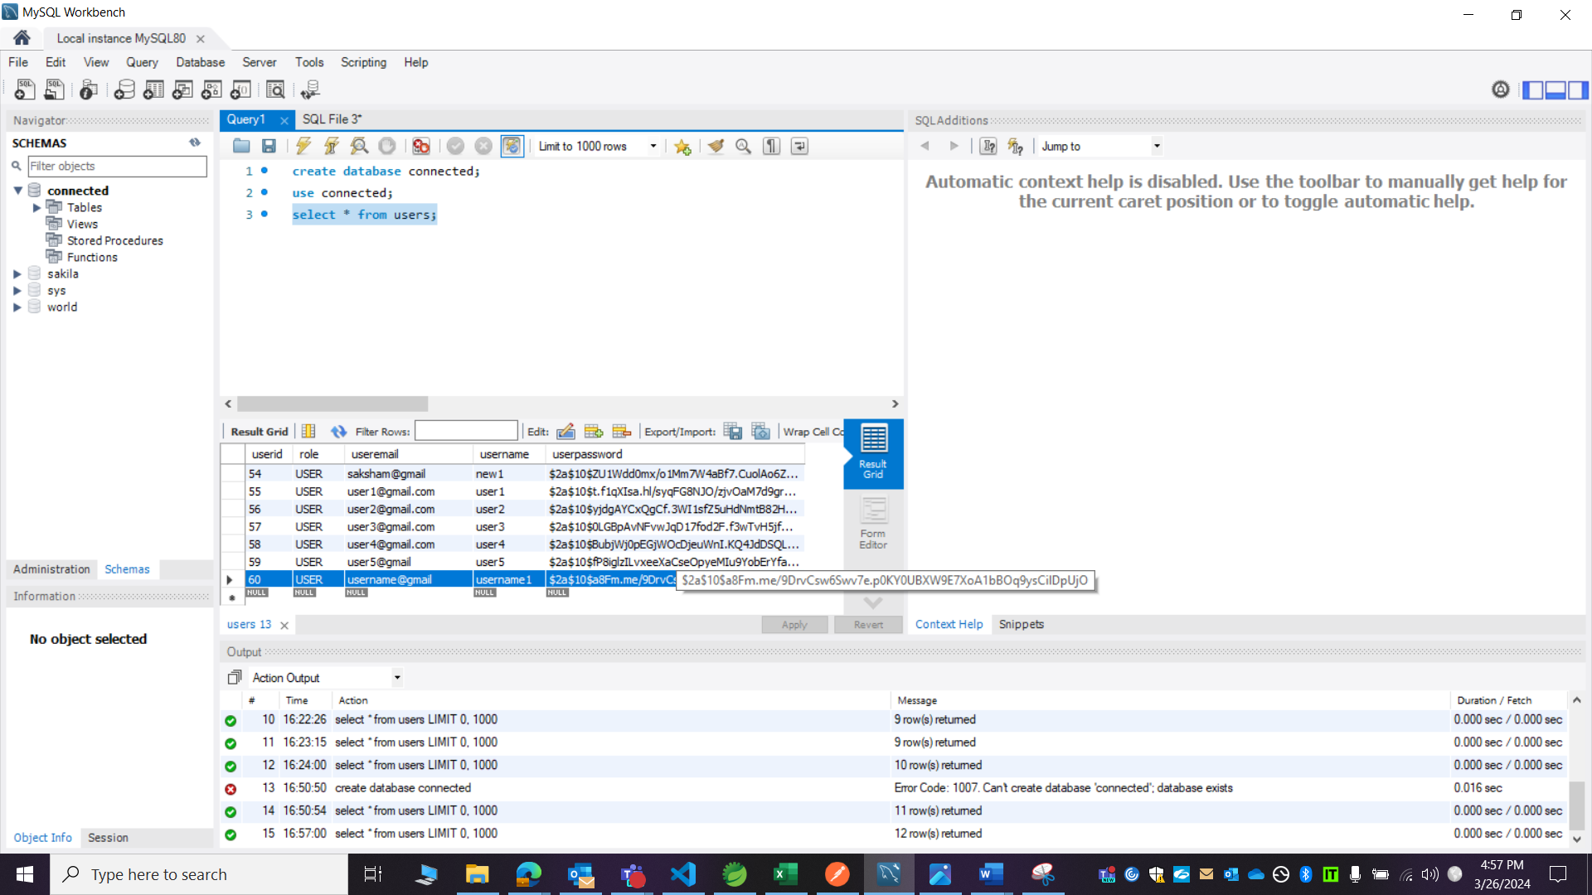

Current functionality: after clicking on submit button nothing is happening.

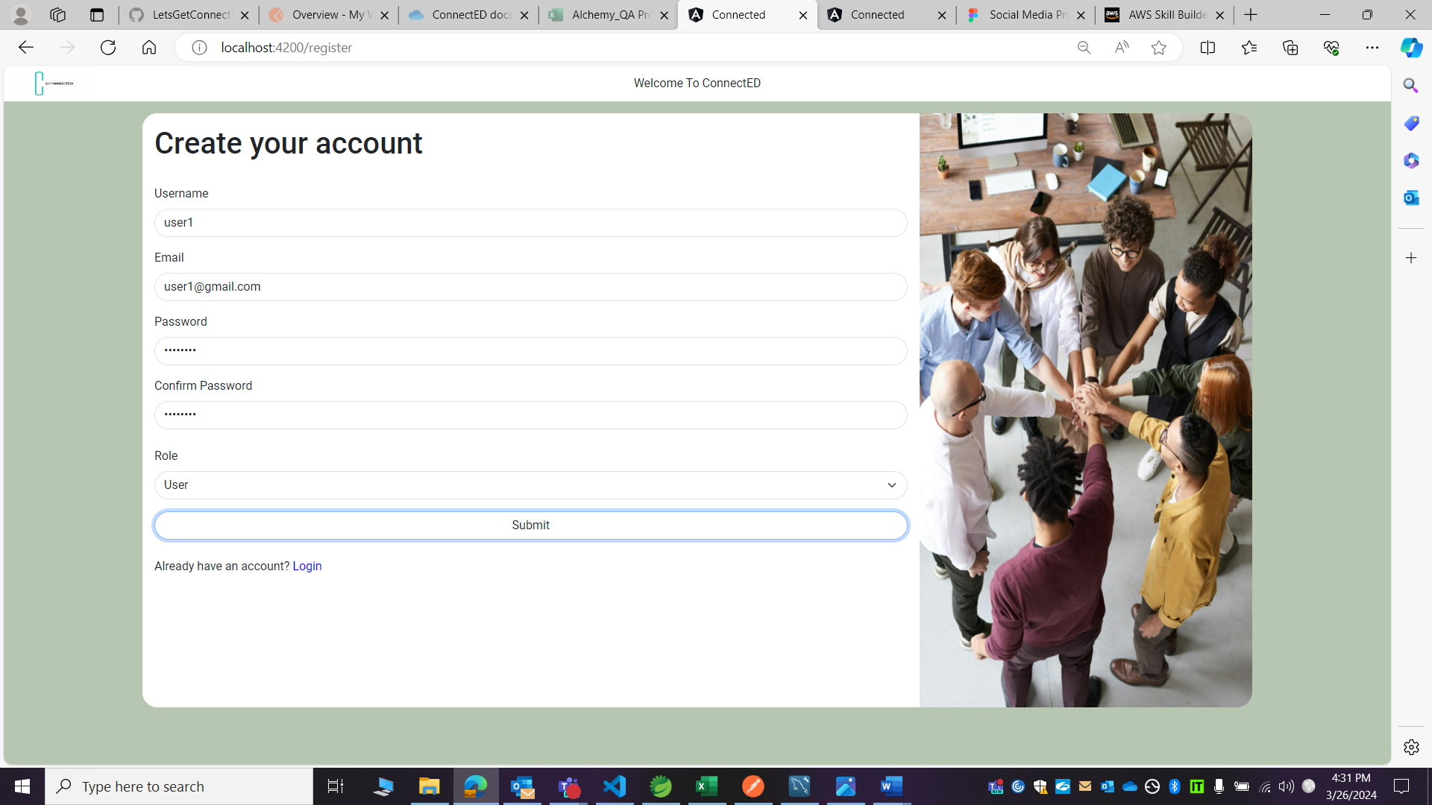

1. If I newly register as a recruiter or an advertiser, then in mysql it is getting registered as a user rather than as a recruiter or an advertiser.

